Tab 2
Regularization Techniques Notes

Business Use Case

Predicting House Prices for a Real Estate Company
A real estate company wants to predict house prices based on several property features.
However, when we include many features, some of them may not truly contribute to price prediction.
This can cause overfitting, where the model learns noise instead of real patterns.

That’s where Regularization techniques help solve this problem.

Dataset Structure
We have a dataset with 350 observations (houses sold).

Target Variable
HousePrice

Features
Feature | Description
SquareFootage | Total area of the house
Bedrooms | Number of bedrooms
Bathrooms | Number of bathrooms
AgeOfHouse | Age of the property
DistanceToCityCenter | Distance to main city
NearbySchoolsRating | Average rating of nearby schools
CrimeRate | Crime rate in the locality
PropertyTaxRate | Local property tax percentage
GarageSize | Number of vehicles garage can hold
LotSize | Total land area
Total observations = 350

Tab 1
Regularization Techniques Notes

Terminology Alert
- “Regularization” - To Control Overfitting
- “Optimization” - To improve model performance or evaluation metrics

Regularization is mainly used in:
- Linear Regression
- Logistic Regression
- Neural Networks
- Many ML models
It helps prevent overfitting.
Today we will apply for Linear Regression.

1. Problem Without Regularization
When we train a Multiple Linear Regression, the model estimates coefficients.

The prediction equation becomes:
HousePrice = β₀ + sum of
- β₁ × SquareFootage
- β₂ × Bedrooms
- β₃ × Bathrooms
- β₄ × AgeOfHouse
- β₅ × DistanceToCityCenter
- β₆ × NearbySchoolsRating
- β₇ × CrimeRate
- β₈ × PropertyTaxRate
- β₉ × GarageSize
- β₁₀ × LotSize
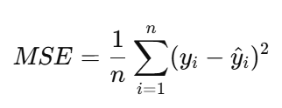
The model estimates the coefficients by minimizing the Cost Function.

2. Core Goal of Regularization
We add a penalty term (λ – lambda) to the cost function.

Why?
Because when slopes (coefficients) become too large:
- Model becomes too sensitive
- High Variance
- Overfitting
- Poor generalization
So we penalize large coefficients.

Types of Regularization

1. Ridge Regression (L2 Regularization)
Penalty term:
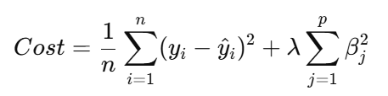

What it does:
- Shrinks ALL coefficients
- Never makes them exactly zero
- Keeps all features
- Good when features are correlated
Intuition:
It smoothens steep slopes.

Key Idea:
It reduces magnitude, not eliminate.

2. Lasso Regression (L1 Regularization)
Penalty term:
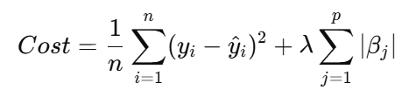

What it does:
- Can shrink some coefficients to EXACTLY zero
- Performs feature selection
- Automatically removes less important features
Why does it eliminate coefficients?
Optimization prefers exact zero sometimes.

That’s why Lasso does feature selection.

3. Elastic Net
Combination of L1 + L2:
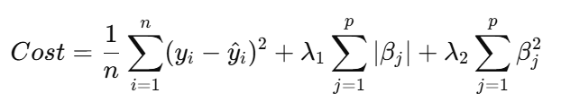

What it does:
- Shrinks coefficients
- Eliminates some features
- Works well when:
  - Many correlated features
  - High dimensional data
Remember !!!
Without Execution, Learning is Useless.

Regards,
AI Coach John

CEO & Founder of ProITbridge.
Youtube: https://www.youtube.com/@aicoachjohn
LinkedIN:https://www.linkedin.com/in/aicoachjohn/
Instagram: https://www.instagram.com/john_the_ai_coach/
Website: https://www.proitbridge.com/

